## Common problems of Stray Snail

### The code can not be burned

The reason why the code cannot be burned is probably that the Bluetooth switch is turned on, and the Bluetooth is also connected to the serial port Tx,Rx, which will affect the program burning. If the Bluetooth switch is turned off, the program can be successfully burned.

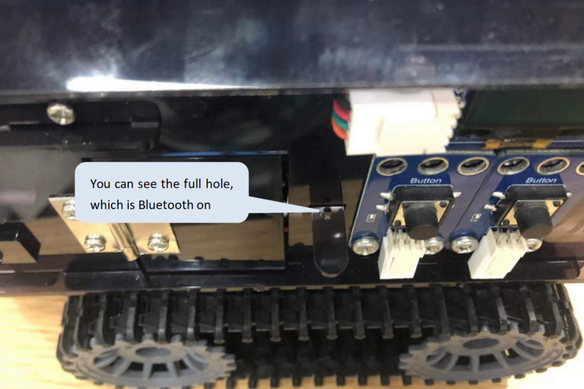

### Bluetooth APP fails to control Stray Snail

（1）Burn the code of Bluetooth control.

（2）Bluetooth is not turned on.

Drag the connecting rod outward to open the Bluetooth, as shown in the figure below.



### Removing and Installing Batteries

Remove the roof panel below and replace the battery.

